* [**Excel-公式中使用萬用字元**](http://isvincent.pixnet.net/blog/post/27986803)

分享: [7Headlines](javascript:(function()%7bvar%20pixheadlines=document.createElement('script');pixheadlines.setAttribute('language','javascript');pixheadlines.setAttribute('src','http://www.7headlines.com/static/js/clip.min.js?random=840.2794182766229');document.getElementsByTagName('head')%5b0%5d.appendChild(pixheadlines);%7d)();) facebook PLURK twitter

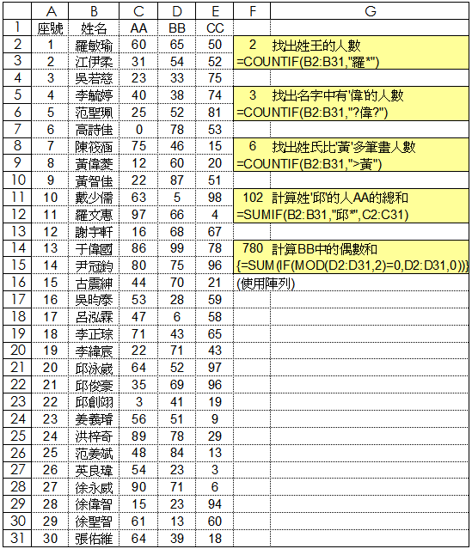

**您或許對這些文章有興趣:**